Assessment 2

**Request for Proposal (RFP)**

Aussie Business Buzz (ABB)

The Vibrant and successful company Aussie Business Buzz (ABB) specialises in the selling of a wide variety of technology products, such as PCs, laptops, Phones and routers. To satisfy the expanding needs of its clientele, ABB also offers professional device repair services and a wide range of mobile device accessories.

Realising how important technology is to its business, ABB is currently looking for creative and seasoned suppliers to help build all -inclusive integrated system. The core of ABB’s operations is expected to be this system, which will initially serve its four branch stores and be built to grow with the company as it grows into other locations.

# 3. Software Development Methods, Processes, and Techniques

Report comparing the adoption of Scrum and Waterfall methodologies.

**Introduction:**

In the dynamic landscape of software development, choosing the right development methodology is crucial for project success. Two prominent methodologies, Scrum and Waterfall, represent distinct approaches to managing software development projects. This report aims to provide an overview of the Agile mindset, describe the Scrum process, outline the Waterfall methodology, and offer guidelines for determining their suitability for specific projects. The focus will be on delineating the differences between Agile (Scrum) and Waterfall methodologies.

**Agile Methodology**

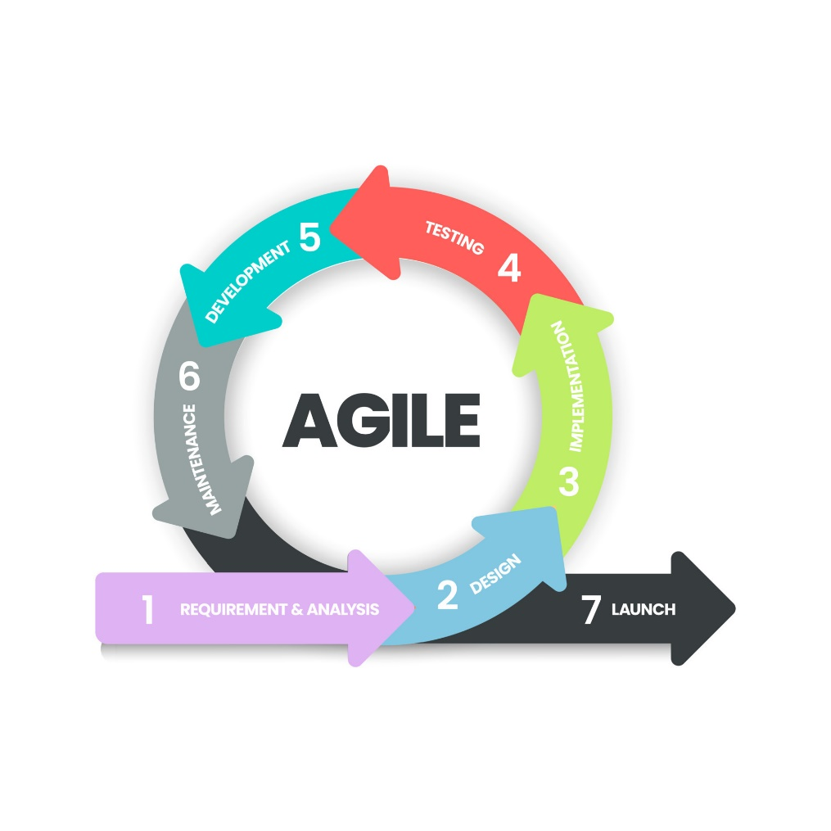Agile represents a collaborative approach for project teams, breaking down work into distinct stages and incorporating continuous customer involvement. Progress is regularly monitored at each stage, distinguishing it from conventional methods by enabling simultaneous development and testing to maintain synchronization.

This approach is driven by the Agile Manifesto, which prioritizes customer satisfaction through continuous delivery and embraces change as a competitive advantage.

12 fundamental principles from Manifesto:

1. Customer satisfaction remains the foremost priority, achieved through the rapid and consistent delivery of results.
2. Embracing changes in the environment at any stage of the process is encouraged to provide customers with a competitive advantage.
3. Products or services are delivered with increased frequency.
4. Close collaboration and regular communication between stakeholders and developers occur on a daily basis.
5. Motivation among all stakeholders and team members is sustained to attain optimal project results. Teams are equipped with the necessary tools, support, and trust to fulfill project goals.
6. Face-to-face meetings are regarded as the most efficient and effective means of ensuring project success.
7. The ultimate gauge of success is the delivery of a completed and functional product.
8. Agile processes support sustainable development by ensuring that development teams and stakeholders can maintain a steady and continuous pace.
9. Consistently prioritizing technical excellence and proper design enhances agility.
10. Simplicity is deemed crucial in all aspects of the development process.
11. Teams that can self-organize are more likely to devise optimal designs and successfully meet requirements.
12. Teams utilize regular intervals to enhance efficiency by making small adjustments to their approach.

<https://agilemanifesto.org/principles.html>